**MNIST ALGORITHM**

**CODE AND OUTPUTS:**

import tensorflow as tf

(x_train, y_train), (x_test, y_test) = tf.keras.datasets.mnist.load_data()

import matplotlib.pyplot as plt

%matplotlib inline

image_index = 7777

print(y_train[image_index])

plt.imshow(x_train[image_index], cmap='Greys')

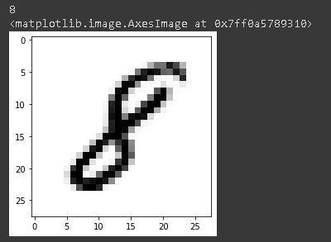

x_train.shape



x_train = x_train.reshape(x_train.shape[0], 28, 28, 1)

x_test = x_test.reshape(x_test.shape[0], 28, 28, 1)

input_shape = (28, 28, 1)

x_train = x_train.astype('float32')

x_test = x_test.astype('float32')

x_train /= 255

x_test /= 255

print('x_train shape:', x_train.shape)



from tensorflow.keras.models import Sequential

from tensorflow.keras.layers import Dense, Conv2D, Dropout, Flatten, MaxPooling2D

model = Sequential()

model.add(Conv2D(28, kernel_size=(3,3), input_shape=input_shape))

model.add(MaxPooling2D(pool_size=(2, 2)))

model.add(Flatten())

model.add(Dense(128, activation=tf.nn.relu))

model.add(Dropout(0.2))

model.add(Dense(10,activation=tf.nn.softmax))

model.compile(optimizer='adam',

              loss='sparse_categorical_crossentropy',

              metrics=['accuracy'])

model.fit(x=x_train,y=y_train, epochs=5)

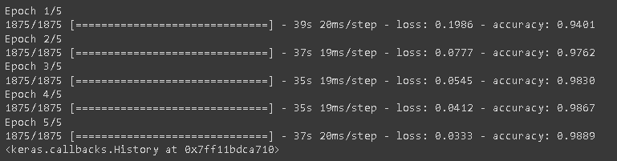

model.evaluate(x_test, y_test)



image_index = 50

plt.imshow(x_test[image_index].reshape(28, 28),cmap='Greys')

pred = model.predict(x_test[image_index].reshape(1, 28, 28, 1))

print(pred.argmax())

